# REGISTRATION OF PATIENTS

In the event the patient is not already in the Master Patient Index from another participating provider, they must first be registered with the HIE before managing patient consent.

From the Census screen, choose the **Registration** tab. Next, select **Non Data Contributor** as the institution. Then, enter as much information as you have for the patient. First Name, Last Name, and DOB are the minimum requirements to register a patient. Click **Next** to review the New Patient information which will appear to the right of the *Patient Information* section. Then click **Register Patient** when done.

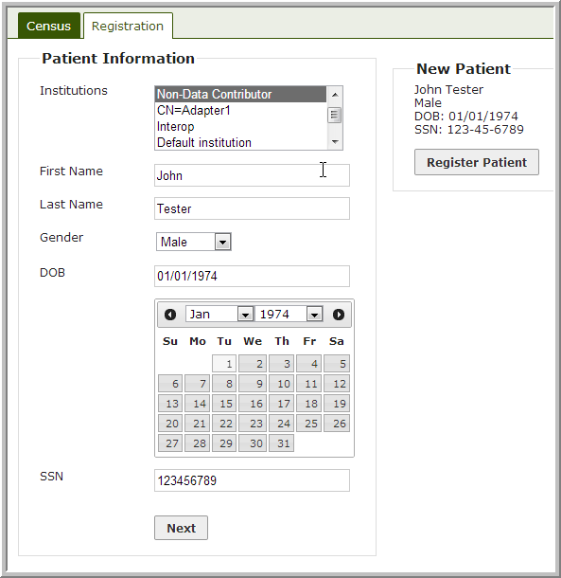

You will then be taken to the Census screen described in the “Managing Patient Consent Form” section where you can complete the opt-out process.